SAP Ariba Network Accounts for our Suppliers

Updating your Account type to access ibuy (SAP Ariba) at Transgrid

SAP Ariba supplier accounts

Transgrid uses the **Ariba Network** to manage its sourcing and procurement activities and to collaborate with you, our suppliers.

As previously communicated, it is **free** to ‘sign up’ and create a **Standard SAP Ariba supplier** account for you to commence collaborating with Transgrid.

Our communication also advised that if you elect to have an **Enterprise SAP Ariba account**, **you will incur fees** **payable** to SAP Ariba directly, once certain volume thresholds are met. This will be at **your own expense** **and directly payable to SAP Ariba.**

What you need to know

Our record shows that you are holding an Enterprise SAP Ariba supplier account.

If you have elected to have an Enterprise SAP Ariba account, and are happy to pay the associated account fees, directly to SAP Ariba, no further action is required.

Please note, that while the Enterprise SAP Ariba account provides suppliers with a higher level of functionality, you only require a Standard account to collaborate with Transgrid.

What you need to do

In the event you do ***not*** wish to incur any fees from SAP Ariba for using an Enterprise account, we recommend, (without prejudice), that you contact SAP Ariba directly to revert your Enterprise account back to Standard account, before any volume thresholds are met.

**How do I downgrade my fully enabled Enterprise account to a Standard account?**

Your account may be eligible for a downgrade if the following criteria are met:

* You must ***not*** have any outstanding supplier fees. (SAP Ariba will revert your Enterprise account back to a Standard account, ***only after you pay*** any SAP fees for usage of the Enterprise account to date, if incurred).
* Your Order Routing Method must be Email and you cannot have any integration configured (cXML, EDI, Punch-Out, CIG).
* Supply Chain Collaboration (SCC) must not be enabled. (SCC must be disabled for SCC relationships by respective buyers).
* You should not have any created Reports. (You will lose access to any created reports).
* You should not have any pending Enablement Tasks related to catalogues/SCF.
* You should not have Invoice Archiving configured. (You will lose access to the archive).

If all the above listed criteria are met, please contact [SAP Ariba Customer Support](https://www.ariba.com/contact-us). Additional verification with the account administrator will need to be performed over the telephone. Once completed, SAP Ariba will forward your request for further review to perform the requested account downgrade from an Enterprise Account to a Standard Account.

To change your account type, you can submit a call back request with SAP Ariba Support and request a downgrade, which you can do within your business SAP Ariba network account.  An overview is provided on the following link: [https://www.ariba.com/support/supplier-support](https://protect-au.mimecast.com/s/VCC1C71Z48iE2p1Xs8eT7J?domain=ariba.com)

**Ready to change your SAP Ariba account?**

Please see below for a Quick Reference Guide on:

* + 1. How to contact Business Network Customer Support as a supplier
    2. Seek further assistance, and
    3. Related additional information.

For questions regarding when you should contact your customer, e.g. Transgrid, see [Do I contact Ariba or my customer when I have a question or issue](https://helpcenter.ariba.com/index.html?sap-language=en#/item&/i/164016)? Thank you in advance for your time, we look forward to continuing to work with you in the future.

Contact us

If you have any queries, please do not hesitate to contact the **Procurement Systems & Operations Team** at [procurement.enquiries@transgrid.com.au](mailto:procurement.enquiries@transgrid.com.au) or by telephone on (02) 9620 0140.

Procurement Systems & Operations Team / Supply Chain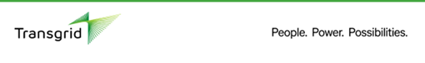

Guide to Changing your SAP Ariba Account

**Ready to downgrade your SAP Ariba Enterprise account to a Standard Account**?

For downgrading your Enterprise account to a Standard account, please complete steps 1-7.

From your [Business Network Customer Support screen](https://service.ariba.com/Supplier.aw/125044049/aw?awh=r&awssk=f9x4dDsf&dard=1&ancdc=1):

1. Click the help https://support.ariba.com/images_RTE/17460560b117420d7f3image_90094863141622218561513.png icon in the upper-right corner of the application.

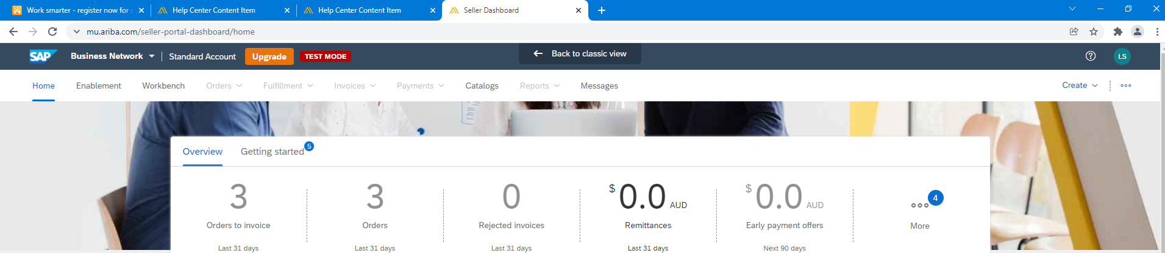

1. Click **Support** (either in the bottom-right corner next to the https://support.ariba.com/images_RTE/17460560b117420d7f3image_90094863141622218561513.png icon or at the top of the help menu).

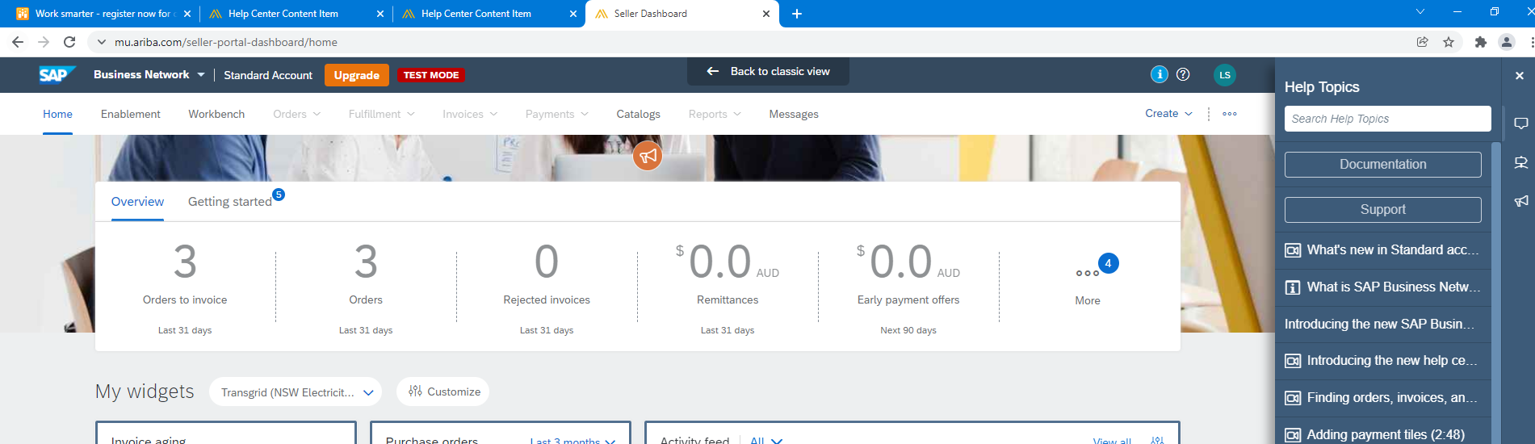

1. Click the **Contact us**tab.

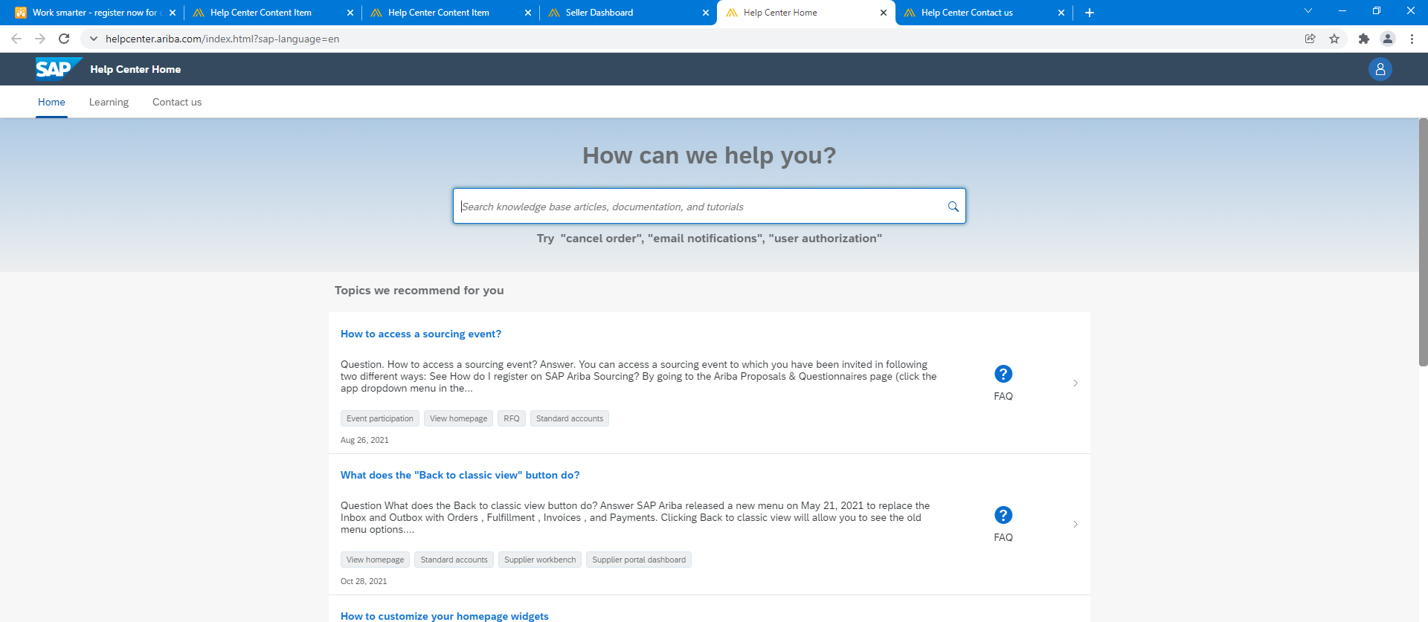

1. To contact SAP Support to request your account downgrade, please click **Contact Us** on the right.

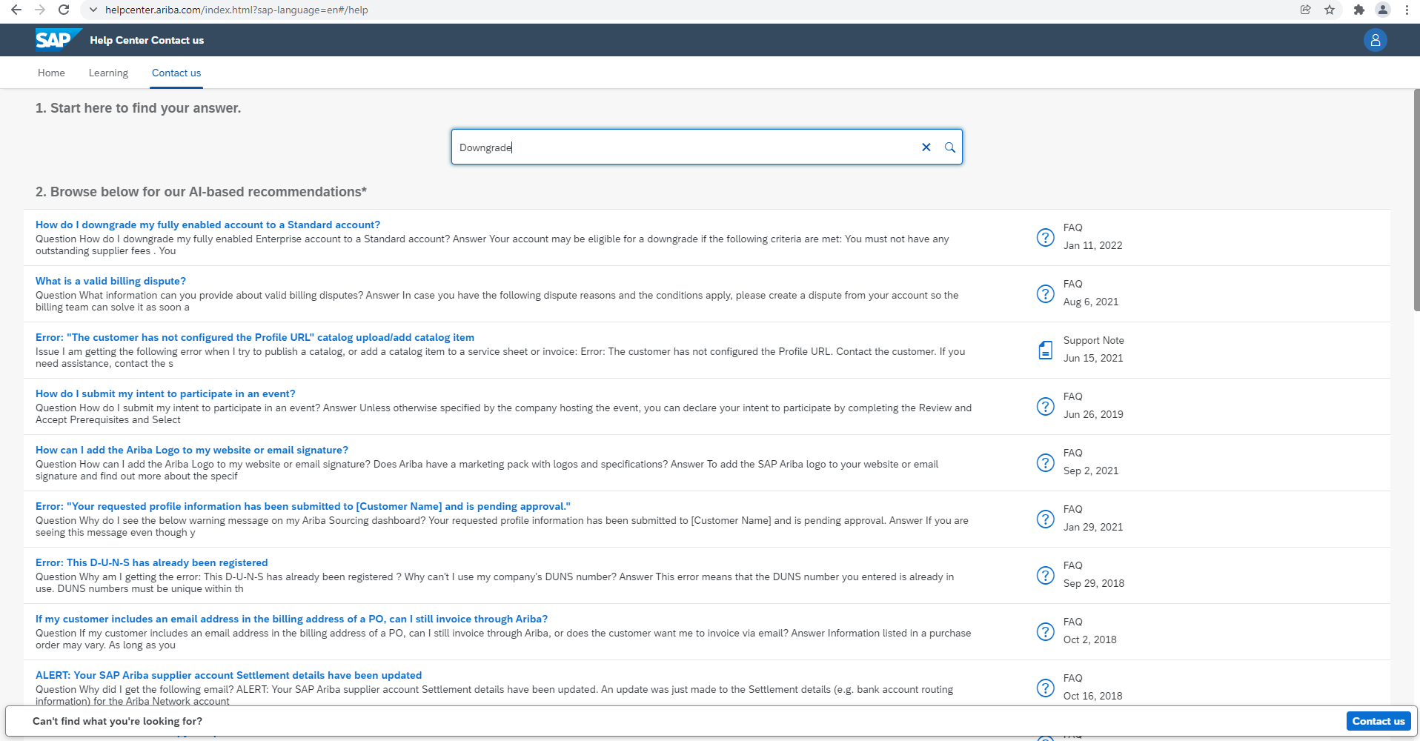

1. On the following screen, please fill out as much of the form detail as possible.

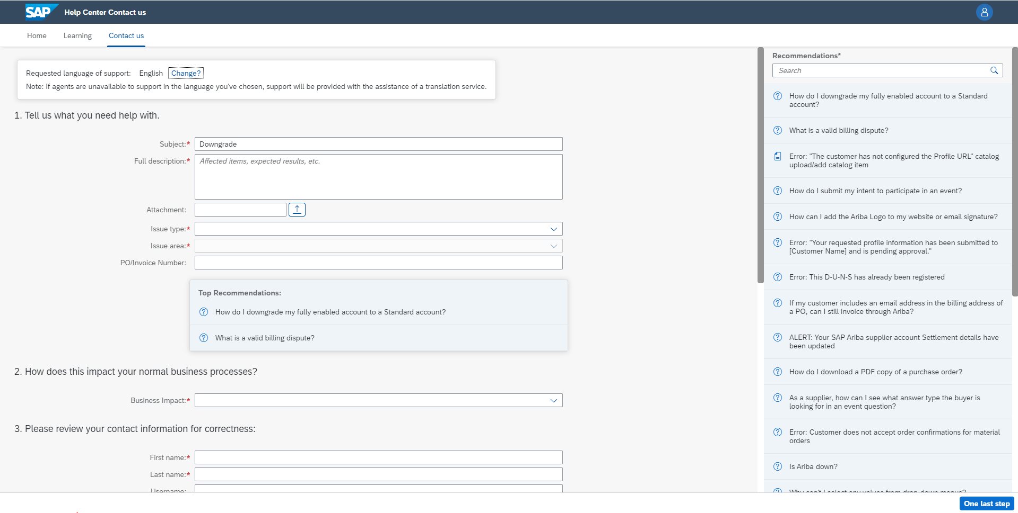

1. Click **One last step** in the bottom-right.
2. Select your contact method and click **Submit.**

This completes the request to downgrade your SAP Ariba account.

**Unable to login? - Additional Information**

The above steps are for the situation when **you are able to login**. In case you are **not able to login**, please follow the steps below. Access [https://supplier.ariba.com](https://supplier.ariba.com/).

Repeat the following steps:

1. Click the help https://support.ariba.com/images_RTE/17460560b117420d7f3image_90094863141622218561513.png icon in the upper-right corner of the application.
2. Click **Support**(either in the bottom-right corner next to the  icon or at the top of the help menu).
3. Click the **Contact us**tab.

You will see **Register on Ariba Network**, **Reset my password**, **Forgot username**, **Unsubscribe** tabs.

Select one and click on a button about your question/ issue under **Choose from the options to continue**section to learn more and get help.

**Contact us**

If you have any queries, please do not hesitate to contact the **Procurement Systems & Operations Team** at [procurement.enquiries@transgrid.com.au](mailto:propcurement.enquiries@transgrid.com.au) or by telephone on (02) 9620 0140.

Procurement Systems & Operations Team / Supply Chain

